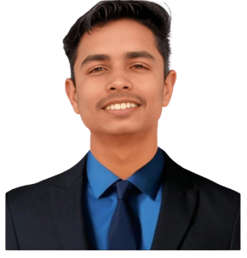

Certifications

* Python Programming 14 Dec – 31 Dec 2022
* Digital Marketing 1 May – 11 May 2023
* Hack-A-Thon 2024 16 Feb – 17 Feb 2024
* Foundation of Cloud IoT Edge ML Feb -- Apr 2024
* Mern Stack 14 oct – 25 Oct 2024
* Sensor-Network and Cloud IoT 1 Apr – 12 Apr 2025
* Python 3.4.3 1 Feb – 21 May 2025

**ADHAR TYAGI**

Frontend Developer

🖀 +91 8171034485 🖄 [adhartyagi1234@gmail.com](mailto:adhartyagi1234@gmail.com) 🌍 Dehradun, India

**Career Objective**

Aspiring front end developer with a strong foundation in Html, CSS, JS and currently pursuing a B.Tech in computer science (2020-2026). Passionate about creating user friendly web interfaces and bringing innovative ideas to life. Seeking opportunities to contribute technical expertise and creative skills to a dynamic development team.

**Education**

**Bachelor of Technology in Computer Science May 2026**

JB Institute of Technology, Shankarpur, Dehradun

**Higher Secondary Education (12th Grade) May 2022**

Shri Guru Ram Rai Public School, Muzaffarnagar

**Secondary Education (10th Grade) May 2020**

Celestial Angles Public High School, Barla, Muzaffarnagar

**Technical Skills**

* Computer Skills
* Internet Browsing
* Programming
* WordPress

**HOBBIES**

* Reading Books
* Sports
* Cooking